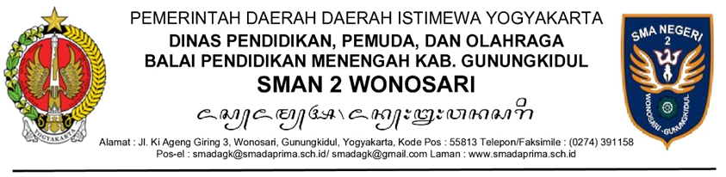

SURAT PERINTAH
NOMOR ........................

Menimbang | : | a. | bahwa ....................................................................................;
 |  | b. | bahwa ....................................................................................;
Dasar | : |  | ...............................................................................................;
 |  |  | ...............................................................................................;
Memberi Perintah
Kepada | : |  | ...............................................................................................;
 |  |  | ...............................................................................................;
 |  |  | dan seterusnya.
Untuk | : |  | ...............................................................................................;
 |  |  | ...............................................................................................;
 |  |  | ...............................................................................................;
 |  |  | dan seterusnya.

Tanggal Bulan Tahun

Kepala SMAN 2 Wonosari,

(Tanda Tangan dan Cap)

Drs. Tiya, M.M.

